

|  |
| --- |
| Software Design Document |
| Contraceptives Logistics Management Information  System (cLMIS)  Release: R1 |
| Prepared by FO Islamabad Team  John Snow Inc.  February 26, 2014 |

Revision History

|  |  |  |  |
| --- | --- | --- | --- |
| **Name** | **Date** | **Reason For Changes** | **Version** |
| Pakistan Field Office | 17 Aug 2013 | First Draft | 1.0 |
| Pakistan Field Office | 14 Sep 2013 | Updated Draft | 1.1 |
| Pakistan Field Office | 3 Oct 2013 | Updated Draft | 1.2 |
| Pakistan Field Office | 24 Feb 2014 | Finalized Technical Doc | 2.0 |

Table of Contents

Acronyms 9

1. Introduction 5

1.1 Purpose 5

1.2 Document Conventions 8

1.3 Intended Audience and Reading Suggestions 8

1.4 Product Scope 9

2. Overall Description 11

2.1 Stakeholders 11

2.2 User Types 12

2.3 Project Documentation 13

2.4 Assumptions and Dependencies 13

3. External Interface Requirements 15

3.1 User Interfaces 15

3.2 Hardware Interfaces 15

3.3 Software Interfaces 15

3.4 Communications Interfaces 15

4. Functional Requirements 17

4.1 Introductory remarks 17

4.2 Secure data entry and role based access 18

4.2.1 Forgot Password 18

4.2.2 Welcome User / Home Page 19

4.2.3 Change Password 19

4.2.4 Logoff 20

4.3 LMIS Guest and Stakeholder Specific User Requirements 21

4.3.1 Geographical summary of logistics indicators 21

4.3.2 National Summery by Stakeholders 22

4.3.3 Identify Stock Imbalances 22

4.3.4 Non Reporting warehouse/stores 22

4.3.5 Stock availability status of different layers of geographical Warehouses and   
stores by product and stakeholders 23

4.3.6 Yearly consumption and stock status of Central/Provincial warehouses 23

4.3.7 Yearly consumption and Stock Status of Provinces 23

4.3.8 Private sector annual report 23

4.3.9 Public and private stakeholders Comparison of logistic indicators by products 24

4.3.10 Graphs for representing different logistic indicators 24

4.4 Stakeholder Specific User’s Requirements 25

4.4.1 Data entry to LMIS 25

4.4.2 Data Layers 26

4.4.3 Viewing Reported data of different months 26

4.4.4 Data can be exported to spreadsheets 26

4.4.5 Data can be imported to LMIS 26

4.5 LMIS Administrator Requirements 27

4.5.1 LMIS Administration should be able to manage users 27

4.5.2 LMIS Administration should be able to manage warehouses 28

4.5.3 LMIS Administration should be able to manage locations 28

4.5.4 LMIS Administration should be able to manage stakeholders 29

4.5.5 Managing Stakeholder’s Office 29

4.5.6 Managing Stakeholder’s Products 29

4.5.7 LMIS Administration should be able to manage products 30

4.5.8 LMIS Administration should be able to manage groups 30

4.5.9 Manage the Month of Stock scale data for products. 30

4.5.10 Create/Update/Delete product types for commodities 31

4.5.11 Create product categories 31

4.5.12 Create/Update/Delete project status identifiers 31

4.5.13 Approve Waiting Data 32

4.6 PC Client / offline module 32

5. Use Cases 35

Index of Use Cases 36

5.1 Login 37

5.2 Viewing Warehouse Monthly Report 38

5.3 Report Monthly Data 40

5.4 Viewing of Analytical Report – National 43

5.5 Viewing of Analytical Report – Provincial 45

5.6 Viewing of Analytical Report – District 47

5.7 Viewing of Analytical Report – Stakeholder 49

5.8 Viewing Central/Provincial WH Report 51

5.9 Viewing Provincial Yearly Report 52

5.10 Viewing Private Sector Yearly Report 53

5.11 Viewing Public-Private Sector Report 54

5.12 Viewing Stock Availability 55

5.13 Viewing Non-Reported Districts 57

5.14 Comparison Graphs 58

5.15 Simple Graphs 59

5.16 Administrator Use Cases 60

5.16.1 Creating Users 60

5.16.2 Creating Warehouses 61

5.16.3 Creating Locations 62

5.16.4 Creating Stakeholders 63

5.16.5 Creating Stakeholders Offices 64

5.16.6 Managing Products 65

5.16.7 Managing MOS Scale 66

6. Nonfunctional Requirements 69

6.1 Technical Requirements 69

6.2 System Initialization 70

6.3 Performance Requirements 71

6.4 Security Requirements 72

6.5 General Characteristics 73

6.6 Management 73

6.7 Safety Requirements 74

6.8 Software Quality Attributes 74

7. High Order Concepts 137

8. Data Entry Flow 139

9. Logistics Indicators Calculations 141

10. Architectural Details 145

10.1 Client Browser Interaction with cLMIS Server 145

10.2 High Level Features of cLMIS 146

10.3 cLMIS Data Entry Point Infrastructure Implementation 147

10.4 Scenario: Internet is present for using cLMIS 148

11. Database Schema 151

11.1 Item Information 151

11.2 Cold Chain Asset 154

11.3 Cold Chain Asset Transfer 157

12.1 Cold Chain Asset Status 159

12.2 Location information 160

12.3 Users Information 162

12.4 Inventory Information 165

12.5 Warehouse information 168

12.6 Warehouse Data 170

12.7 Warehouse Users 172

12.8 Stakeholders 173

12.9 Stakeholder Items 175

12.10 Reports 176

12.11 Favorite Graph Settings 181

12.12 Period 183

12.13 Chart Type 184

12.14 Placement information 185

12.15 Product Placement Quantity 188

12.16 Configuration Information 189

12.17 Need to Delete Tables 190

13. cLMIS Screens 193

14. Appendix 5: Glossary 209

# Acronyms

|  |  |
| --- | --- |
| **Name** | **Meaning** |
| BHU | Basic Health Unit |
| DMO | District Medical Officer |
| GOP | Government of Pakistan |
| HF | Health Facility |
| ICT | Information Communications Technologies |
| IT | Information Technology |
| JSI | John Snow, Inc. |
| LHW | Lady Health Worker |
| LMIS | Logistics Management Information System |
| MDG | Millennium Development Goal |
| MIS | Management Information System |
| MNHRC | Ministry of National Health Services, Regulation and Coordination |
| MIPC | Ministry of Inter Provincial Coordination |
| SDP | Service Delivery Point |
| SMS | Short Message Service |
| SOP | Standard Operating Procedure |
| UC | Union Council |
| UNICEF | United Nations Children's Fund |
| USAID | United States Agency for International Development |
| WHO | World Health Organization |
| WMS | Warehouse Management System |

**Architecture**

# Architectural Details

## Client Browser Interaction with cLMIS Server

## High Level Features of cLMIS

## cLMIS Data Entry Point Infrastructure Implementation

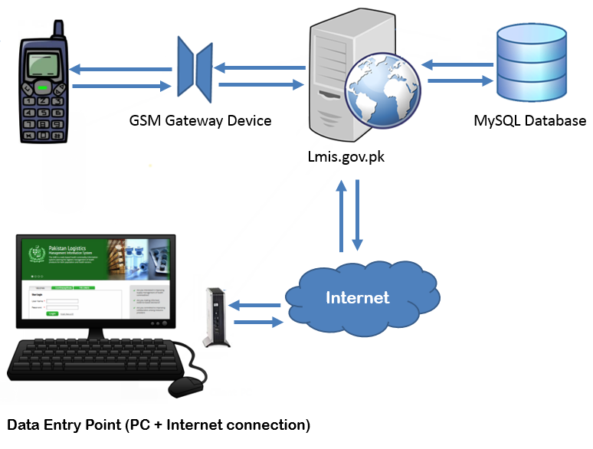

## Scenario: Internet is present for using cLMIS

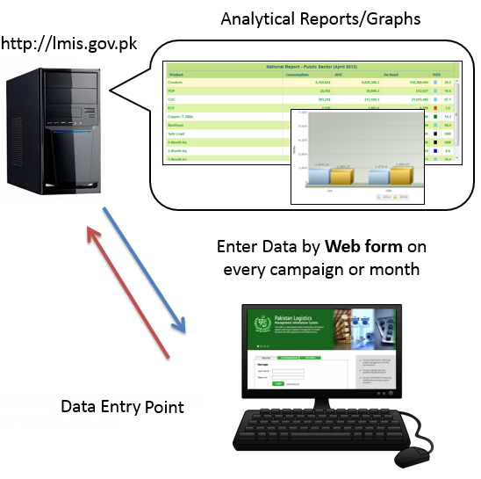

**Database Schema**

# Database Schema

## Item Information

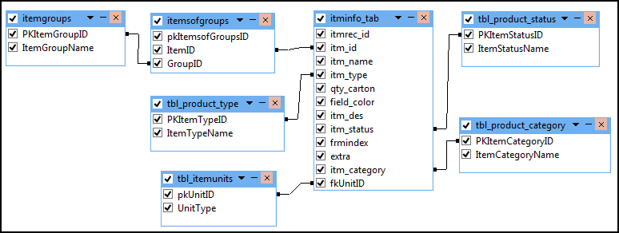**Relationship Diagram**

**Table Properties**

|  |  |  |  |  |
| --- | --- | --- | --- | --- |
| **Iteminfo_tab** | | | | |
| **Field Name** | **Description** | **Type** | **Length** | **Null** |
| itmrec_id | Specify the record ID. | Varchar | 15 | No |
| itm_id (PK) | Specify the item ID. It is auto increment. | Int | 10 | No |
| itm_name | Name of the items. | Varchar | 50 | Yes |
| itm_type | It describes the type of each item i.e. pills, injection etc. | Varchar | 30 | Yes |
| qty_carton | It is quantity of each item in a single carton. | Int | 11 | No |
| field_color | It describes the color of the fields. | Varchar | 7 | Yes |
| itm_des | Its item description. | Text | 0 | Yes |
| itm_status | This field tells that whether the item is currently being purchased or not. | Varchar | 10 | Yes |
| frmindex |  | Int | 11 | No |
| extra |  | Varchar | 20 | Yes |
| itm_category (FK) | Specify the item categories (WMS, CS etc) | Varchar | 50 | No |
| fkUnitID (FK) | Specify the item units ID (Doses, Vials, Pcs etc) | Int | 11 | Yes |

|  |  |  |  |  |
| --- | --- | --- | --- | --- |
| **tbl-product_category** | | | | |
| **Field Name** | **Description** | **Type** | **Length** | **Null** |
| PKItemCategoryID (PK) | Specify the item category ID. It is auto increment. | Int | 11 | No |
| ItemCategoryName | Name of the items category. | Varchar | 255 | No |

|  |  |  |  |  |
| --- | --- | --- | --- | --- |
| **tbl_itemunits** | | | | |
| **Field Name** | **Description** | **Type** | **Length** | **Null** |
| pkUnitID (PK) | Specify the item unit ID. It is auto increment. | Int | 11 | NO |
| UnitType | Specify the type of the unit i.e. Doses, Vials or Pcs. | Varchar | 255 | Yes |

|  |  |  |  |  |
| --- | --- | --- | --- | --- |
| **itemgroups** | | | | |
| **Field Name** | **Description** | **Type** | **Length** | **Null** |
| PKItemGroupID (PK) | Specify the item group ID. It is auto increment. | Int | 11 | NO |
| ItemGroupName | Name of the group. | Varchar | 255 | Yes |

|  |  |  |  |  |
| --- | --- | --- | --- | --- |
| **itemofgroups** | | | | |
| **Field Name** | **Description** | **Type** | **Length** | **Null** |
| pkItemsofGroupsID (PK) | Specify the item of group ID. It is auto increment. | int | 11 | No |
| ItemID (FK) | Specify the item ID. | int | 11 | Yes |
| GroupID (FK) | Specify the group ID. | int | 11 | Yes |

|  |  |  |  |  |
| --- | --- | --- | --- | --- |
| **tbl-product-status** | | | | |
| **Field Name** | **Description** | **Type** | **Length** | **Null** |
| PKItemStatusID (PK) | Specify the item status ID. It is auto increment. | int | 11 | No |
| ItemStatusName | Name of the item status. | varchar | 255 | No |

|  |  |  |  |  |
| --- | --- | --- | --- | --- |
| **tbl-product-type** | | | | |
| **Field Name** | **Description** | **Type** | **Length** | **Null** |
| PKItemTypeID (PK) | Specify the item type ID. It is auto increment. | int | 11 | No |
| ItemTypeName | Name of the item type. | varchar | 255 | No |

## Location information

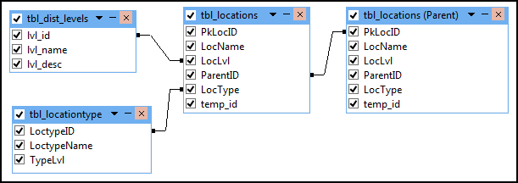**Relationship Diagram**

**Table Properties**

|  |  |  |  |  |
| --- | --- | --- | --- | --- |
| **tbl_locations** | | | | |
| **Field Name** | **Description** | **Type** | **Length** | **Null** |
| PkLocID (PK) | Specify the location ID. It is auto increment. | Int | 11 | No |
| LocName | Name of locations. | Varchar | 100 | Yes |
| LocLvl (FK) | Specify the location level ID( National, Provincial, Division, District, Tehsil, UC etc) | Int | 11 | Yes |
| ParentID | This field describes that which location belongs to which district and province | Int | 11 | Yes |
| LocType (FK) | Specify the location type ID (Country, Province  ,Region, District, Agency, FR, DHQ, THQ, Tertiary Hospital, BMU, Towns etc) | Int | 11 | Yes |
| temp_id |  | Varchar | 11 | No |

|  |  |  |  |  |
| --- | --- | --- | --- | --- |
| **tbl_dist_levels** | | | | |
| **Field Name** | **Description** | **Type** | **Length** | **Null** |
| lvl_id (PK) | Specify the distribution level ID. It is auto increment. | Int | 11 | No |
| lvl_name | Names of the levels.  Division, District, Tehsil, UC | Varchar | 40 | Yes |
| lvl_desc | It describes the location levels (National, Provincial, Division, District, Tehsil, UC etc). | Text | 0 | Yes |

|  |  |  |  |  |
| --- | --- | --- | --- | --- |
| **tbl_locationtype** | | | | |
| **Field Name** | **Description** | **Type** | **Length** | **Null** |
| LoctypeID (PK) | Specify the location type ID. It is auto increment. | Int | 11 | No |
| LoctypeName | Name of the location type. | Varchar | 255 | Yes |
| TypeLvl |  | Int | 11 | No |

## Users Information

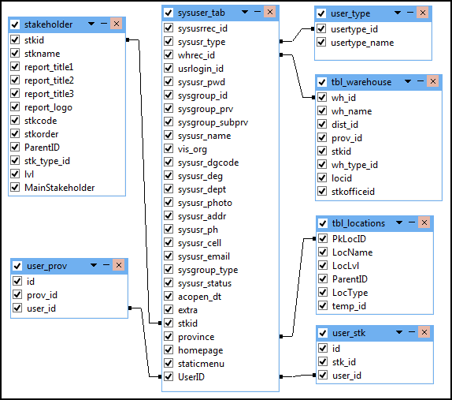**Relationship Diagram**

**Table Properties**

|  |  |  |  |  |
| --- | --- | --- | --- | --- |
| **sysuser_tab** | | | | |
| **Field Name** | **Description** | **Type** | **Length** | **Null** |
| sysusrrec_id | Specify the user record ID. | Varchar | 15 | No |
| sysusr_type | Specify the user type (Administrator, Sub Admin, Data Entry, guests, CC Manager etc) | Varchar | 15 | Yes |
| whrec_id (FK) | Specify the warehouse ID. | Varchar | 15 | Yes |
| usrlogin_id | Login IDs of every authenticated system user. | Varchar | 155 | Yes |
| sysusr_pwd | Passwords of every authenticated system user. | Varchar | 50 | Yes |
| sysgroup_id |  | Varchar | 50 | Yes |
| sysgroup_prv |  | Text | 0 | Yes |
| sysgroup_subprv |  | Text | 0 | Yes |
| sysusr_name | Name of the user. | Varchar | 40 | Yes |
| vis_org |  | Varchar | 50 | Yes |
| sysusr_dgcode |  | Varchar | 10 | Yes |
| sysusr_deg | Designation of each system user | Varchar | 150 | Yes |
| sysusr_dept | Department of each system user | Varchar | 150 | Yes |
| sysusr_photo | Picture of the user. | Blob | 0 | Yes |
| sysusr_addr | Address of the user. | Text | 0 | Yes |
| sysusr_ph | Phone number of the user. | Varchar | 25 | Yes |
| sysusr_cell | Phone number of the user. | Varchar | 25 | Yes |
| sysusr_email | Email address of the user. | Varchar | 50 | No |
| sysgroup_type | Group of system user | Varchar | 10 | Yes |
| extra |  | Varchar | 20 | Yes |
| stkid (FK) | Specify the stakeholder ID. | Varchar | 200 | Yes |
| province (FK) | Specify the province ID. | Varchar | 20 | Yes |
| homepage |  | Varchar | 100 | Yes |
| staticmenu |  | Varchar | 100 | Yes |
| UserID (PK) | Specify the user ID. It is auto increment. | Int | 11 | No |

|  |  |  |  |  |
| --- | --- | --- | --- | --- |
| **user_type** | | | | |
| **Field Name** | **Description** | **Type** | **Length** | **Null** |
| usertype_id (PK) | Specify the user type ID. It is auto increment. | Varchar | 8 | No |
| usertype_name | Name of the system users type. i.e. Administrator, Sub Admin, Data Entry, guests, CC Manager | Varchar | 222 | Yes |

|  |  |  |  |  |
| --- | --- | --- | --- | --- |
| **user_prov** | | | | |
| **Field Name** | **Description** | **Type** | **Length** | **Null** |
| id (PK) | Specify the user province ID. It is auto increment. | Int | 11 | No |
| stk_id (FK) | Specify the stakeholder ID. | Int | 11 | Yes |
| user_id (FK) | Specify the user ID. | Int | 11 | Yes |

|  |  |  |  |  |
| --- | --- | --- | --- | --- |
| **user_stk** | | | | |
| **Field Name** | **Description** | **Type** | **Length** | **Null** |
| id (PK) | Specify the user stakeholder ID. It is auto increment. | Int | 11 | No |
| Prov_id (FK) | Specify the location ID. | Int | 11 | Yes |
| User_id (FK) | Specify the user ID. | Int | 11 | Yes |

## Inventory Information

**Relationship Diagram**

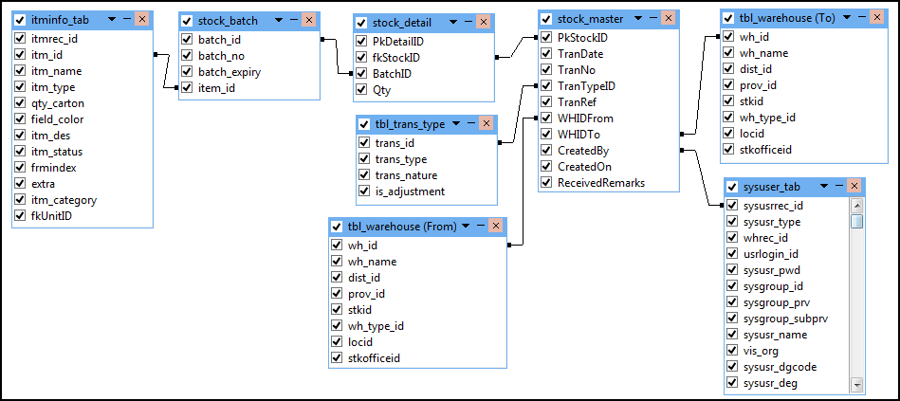

**Table Properties**

|  |  |  |  |  |
| --- | --- | --- | --- | --- |
| **stock_master** | | | | |
| **Field Name** | **Description** | **Type** | **Length** | **Null** |
| PkStockID (PK) | Specify the stock master ID. It is auto increment. | Int | 11 | No |
| TranDate | Specify the transaction date using format dd/mm/yyyy. | Date | 0 | Yes |
| TranNo | Number of the transaction. | Varchar | 100 | Yes |
| TranTypeID (FK) | Specify the transaction type ID(Receive, Issue, Theft, Cold Chain Break, Lost, Lost Recovered) | Int | 11 | Yes |
| TranRef |  | Varchar | 255 | Yes |
| WHIDFrom (FK) | Specify the warehouse issued ID. | Int | 11 | Yes |
| WHIDTo (FK) | Specify the warehouse received ID. | Int | 11 | Yes |
| CreatedBy (FK) | Specify the user ID. | Int | 11 | Yes |
| CreatedOn | Specify the created date. | Date | 0 | Yes |
| ReceivedRemarks | Specify the received remarks. | Varchar | 255 | Yes |

|  |  |  |  |  |
| --- | --- | --- | --- | --- |
| **tbl_trans_type** | | | | |
| **Field Name** | **Description** | **Type** | **Length** | **Null** |
| trans_id (PK) | Specify the transaction type ID. It is auto increment. | Int | 11 | No |
| trans_type | Type of the transaction i.e. Receive, Issue, Theft  Cold Chain Break, Lost, Lost Recovered. | Varchar | 255 | Yes |
| trans_nature |  | Varchar | 1 | Yes |
| is_adjustment |  | Tinyint | 1 | Yes |

|  |  |  |  |  |
| --- | --- | --- | --- | --- |
| **stock_batch** | | | | |
| **Field Name** | **Description** | **Type** | **Length** | **Null** |
| batch_id (PK) | Specify the stock batch ID. It is auto increment. | Int | 11 | NO |
| batch_no | Specify the batch number (alphanumeric) for the product. | Varchar | 100 | Yes |
| batch_expiry | The expiry date of the batch. The date is saved in DB in format: dd/mm/yyyy. | Date | 0 | Yes |
| item_id (FK) | Specify the item ID. | Int | 11 | Yes |

|  |  |  |  |  |
| --- | --- | --- | --- | --- |
| **stock_detail** | | | | |
| **Field Name** | **Description** | **Type** | **Length** | **Null** |
| PkDetailID (PK) | Specify the stock detail ID. It is auto increment. | Int | 11 | No |
| fkStockID (FK) | Specify the stock ID. | Int | 11 | Yes |
| BatchID (FK) | Specify the batch ID. | Int | 11 | Yes |
| Qty | Specify the quantity. | Bigint | 20 | Yes |

## Warehouse information

**Warehouse**

**Relationship Diagram**

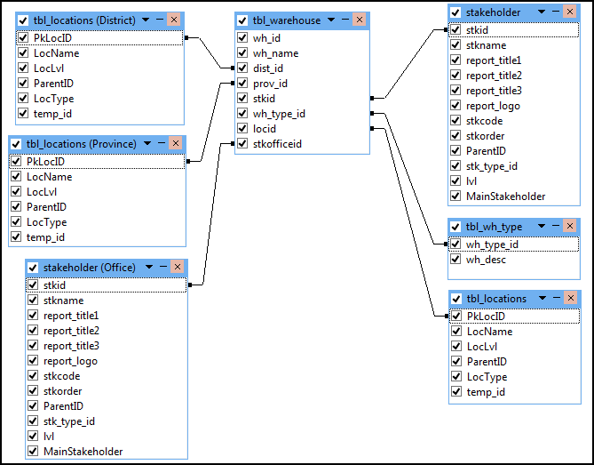

**Table Properties**

|  |  |  |  |  |
| --- | --- | --- | --- | --- |
| **tbl_warehouse** | | | | |
| **Field Name** | **Description** | **Type** | **Length** | **Null** |
| wh_id (PK) | Specify the warehouse ID. It is auto increment. | Int | 11 | No |
| wh_name | Name of the warehouse. | Varchar | 255 | Yes |
| dist_id (FK) | Specify the district ID. | Varchar | 50 | Yes |
| prov_id (FK) | Specify the provine ID. | Int | 11 | Yes |
| stkid (FK) | Specify the stakeholder ID. | Int | 11 | Yes |
| wh_type_id (FK) | Specify the warehouse type ID. | Varchar | 255 | Yes |
| locid (FK) | Specify the location ID. | Int | 11 | Yes |
| stkofficeid (FK) | Specify the stakeholder office ID. | Int | 11 | Yes |

|  |  |  |  |  |
| --- | --- | --- | --- | --- |
| **tbl_wh_type** | | | | |
| **Field Name** | **Description** | **Type** | **Length** | **Null** |
| wh_type_id (PK) | Specify the warehouse type ID. It is auto increment. | Varchar | 255 | No |
| wh_desc |  | Varchar | 255 | Yes |

## Warehouse Data

**Relationship Diagram**

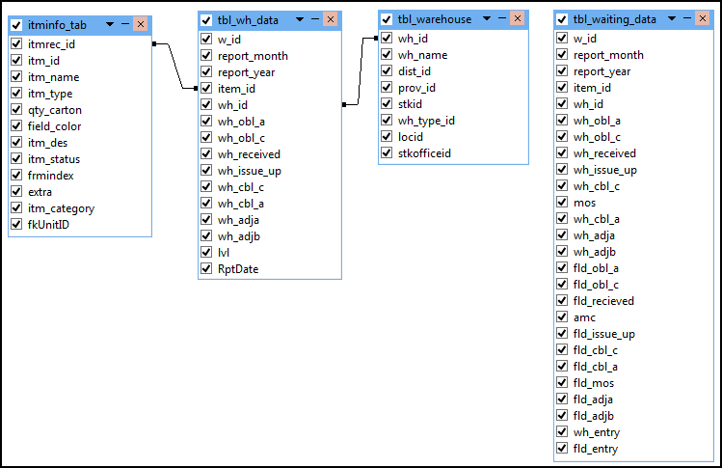

**Table Properties**

|  |  |  |  |  |
| --- | --- | --- | --- | --- |
| **tbl_wh_data** | | | | |
| **Field Name** | **Description** | **Type** | **Length** | **Null** |
| w_id (PK) | Specify the warehouse ID. It is auto increment. | Int | 11 | No |
| report_month | Month in which the report was collected. | Int | 11 | Yes |
| report_year | Year in which the report was collected. | Int | 11 | Yes |
| item_id (FK) | Specify the item ID. | varchar | 15 | Yes |
| wh_id (FK) | Specify the warehouse ID. | Int | 11 | Yes |
| wh_obl_a | Warehouse actual opening balance | Int | 11 | Yes |
| wh_obl_c | Warehouse actual closing balance | Int | 11 | Yes |
| wh_received |  | Int | 11 | Yes |
| wh_issue_up |  | Int | 11 | Yes |
| wh_cbl_c |  | Int | 11 | Yes |
| wh_cbl_a |  | Int | 11 | Yes |
| wh_adja |  | Int | 11 | Yes |
| wh_adjb |  | Int | 11 | Yes |
| lvl |  | Smallint | 6 | Yes |
| RptDate |  | Date | 0 | Yes |

|  |  |  |  |  |
| --- | --- | --- | --- | --- |
| **tbl_waiting-data** | | | | |
| **Field Name** | **Description** | **Type** | **Length** | **Null** |
| w_id (PK) | Specify the warehouse ID. It is auto increment. | int | 11 | No |
| report_month |  | int | 11 | Yes |
| report_year |  | int | 11 | Yes |
| item_id (FK) | Specify the item ID. | varchar | 15 | Yes |
| wh_id (FK) | Specify the warehouse ID. | int | 11 | Yes |
| wh_obl_a |  | int | 11 | Yes |
| wh_obl_c |  | int | 11 | Yes |
| wh_received |  | int | 11 | Yes |
| wh_issue_up |  | int | 11 | Yes |
| wh_cbl_c |  | int | 11 | Yes |
| mos |  | int | 11 | Yes |
| wh_cbl_a |  | int | 11 | Yes |
| wh_adja |  | int | 11 | Yes |
| wh_adjb |  | int | 11 | Yes |
| fld_obl_a |  | int | 11 | Yes |
| fld_obl_c |  | int | 11 | Yes |
| fld_recieved |  | int | 11 | Yes |
| amc |  | int | 11 | Yes |
| fld_issue_up |  | int | 11 | Yes |
| fld_cbl_c |  | int | 11 | Yes |
| fld_cbl_a |  | int | 11 | Yes |
| fld_mos |  | int | 11 | Yes |
| fld_adja |  | int | 11 | Yes |
| fld_adjb |  | int | 11 | Yes |
| wh_entry |  | int | 1 | Yes |
| fld_entry |  | int | 1 | Yes |

## Warehouse Users

**Relationship Diagram**

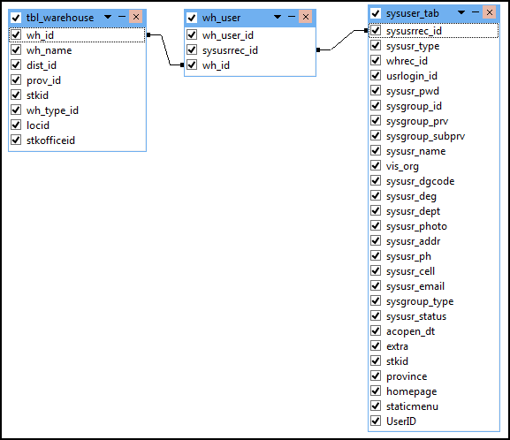

**Table Properties**

|  |  |  |  |  |
| --- | --- | --- | --- | --- |
| **wh_user** | | | | |
| **Field Name** | **Description** | **Type** | **Length** | **Null** |
| wh_user_id (PK) | Specify the warehouse user ID. It is auto increment. | Int | 11 | No |
| sysusrrec_id (FK) | Specify the user ID. | Int | 11 | No |
| wh_id (FK) | Specify the warehouse ID. | Int | 11 | No |

## Stakeholders

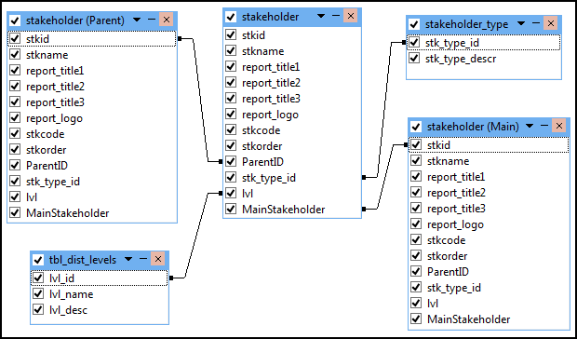**Relationship Diagram**

**Table Properties**

|  |  |  |  |  |
| --- | --- | --- | --- | --- |
| **Stakeholder** | | | | |
| **Field Name** | **Description** | **Type** | **Length** | **Null** |
| Stkid (PK) | Specify the stakeholder ID. It is auto increment. | Int | 9 | No |
| stkname | Name of the Stakeholder. | Varchar | 44 | Yes |
| report_title1 | Name of the report title1. | Varchar | 60 | Yes |
| report_title2 | Name of the report title2. | Varchar | 60 | Yes |
| report_title3 | Name of the report title3. | Varchar | 60 | Yes |
| report_logo |  | Varchar | 60 | Yes |
| stkcode |  | Varchar | 10 | Yes |
| stkorder |  | Tinyint | 2 | Yes |
| ParentID | ID of that stakeholder which comes immediately above each stakeholder. | Int | 9 | Yes |
| stk_type_id (FK) | Specify the stakeholder type ID(Reporting  Suppliers, Manufacturer) | Int | 11 | Yes |
| lvl (FK) | Specify the levels ID(National, Provincial  Division, District, Tehsil, UC etc) | Int | 11 | Yes |
| MainStakeholder | Specify the stakeholder ID. | Int | 11 | Yes |

|  |  |  |  |  |
| --- | --- | --- | --- | --- |
| **stakeholder_type** | | | | |
| **Field Name** | **Description** | **Type** | **Length** | **Null** |
| stk_type_id (PK) | Specify the stakeholder type ID. It is auto increment. | Int | 11 | No |
| stk_type_descr | Types of the stakeholder i.e. Reporting  Suppliers, Manufacturer. | Varchar | 25 | Yes |

## Stakeholder Items

**Relationship Diagram**

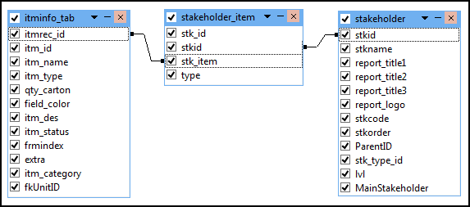

**Table Properties**

|  |  |  |  |  |
| --- | --- | --- | --- | --- |
| **stakeholder_item** | | | | |
| **Field Name** | **Description** | **Type** | **Length** | **Null** |
| stk_id (PK) | Specify the stakeholder item ID. It is auto increment. | Int | 8 | No |
| stkid (FK) | Specify the stakeholder ID. | Int | 11 | No |
| stk_item (FK) | Specify the item ID. | Varchar | 255 | Yes |
| type |  | Varchar | 222 | Yes |

## Reports

**MOS Scale**

**Relationship Diagram**

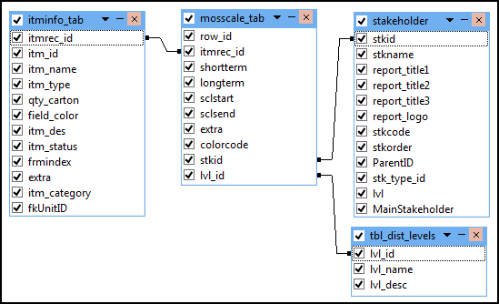

**Table Properties**

|  |  |  |  |  |
| --- | --- | --- | --- | --- |
| **mosscale_tab** | | | | |
| **Field Name** | **Description** | **Type** | **Length** | **Null** |
| row_id (PK) | Specify the mos ID. It is auto increment. | Int | 11 | No |
| itmrec_id (FK) | Specify the item ID. | Varchar | 15 | Yes |
| shortterm |  | Varchar | 5 | Yes |
| longterm |  | Varchar | 30 | Yes |
| sclstart |  | Float | 0 | No |
| sclsend |  | Float | 0 | No |
| extra |  | Varchar | 10 | Yes |
| colorcode | Specify the color. | Varchar | 30 | Yes |
| stkid (FK) | Specify the stakeholder ID. | Int | 11 | Yes |
| lvl_id (FK) | Specify the levels ID(National, Provincial  Division, District, Tehsil, UC etc) | Int | 11 | Yes |

**Reports**

**Relationship Diagram**

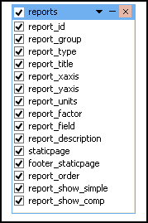

**Table Properties**

|  |  |  |  |  |
| --- | --- | --- | --- | --- |
| **reports** | | | | |
| **Field Name** | **Description** | **Type** | **Length** | **Null** |
| report_id (PK) | Specify the report ID. It is auto increment. | Varchar | 60 | No |
| report_group | Specify the report group(Dispensed, OnHand, MOS etc) | Varchar | 100 | Yes |
| report_type |  | Decimal | 1 | Yes |
| report_title | Title of the report. | Varchar | 60 | Yes |
| report_xaxis |  | Varchar | 60 | Yes |
| report_yaxis |  | Varchar | 60 | Yes |
| report_units |  | Varchar | 60 | Yes |
| report_factor |  | Decimal | 8 | Yes |
| report_field |  | Varchar | 100 | Yes |
| report_description |  | Text | 0 | Yes |
| staticpage |  | Varchar | 100 | Yes |
| footer_staticpage |  | Varchar | 100 | Yes |
| report_order |  | Smallint | 6 | Yes |
| report_show_simple |  | Smallint | 1 | Yes |
| report_show_comp |  | Smallint | 1 | Yes |

**Reports Option**

**Relationship Diagram**

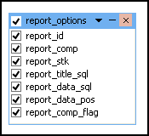

**Table Properties**

|  |  |  |  |  |
| --- | --- | --- | --- | --- |
| **report_options** | | | | |
| **Field Name** | **Description** | **Type** | **Length** | **Null** |
| report_id (PK) | Specify the report ID. It is auto increment. | Varchar | 100 | Yes |
| report_comp |  | Smallint | 1 | Yes |
| report_stk |  | Tinyint | 1 | No |
| report_title_sql |  | Varchar | 1000 | Yes |
| report_data_sql |  | Varchar | 1000 | Yes |
| report_data_pos |  | Smallint | 2 | Yes |
| report_comp_flag |  | Smallint | 1 | Yes |

**Reports Roles**

**Relationship Diagram**

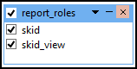

**Table Properties**

|  |  |  |  |  |
| --- | --- | --- | --- | --- |
| **report_roles** | | | | |
| **Field Name** | **Description** | **Type** | **Length** | **Null** |
| Skid (PK) |  | Int | 11 | No |
| skid_view (PK) |  | Int | 11 | No |

## Favorite Graph Settings

**Relationship Diagram**

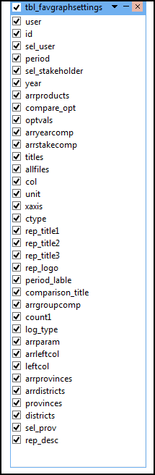

**Table Properties**

|  |  |  |  |  |
| --- | --- | --- | --- | --- |
| **tbl_favgraphsettings** | | | | |
| **Field Name** | **Description** | **Type** | **Length** | **Null** |
| user | Name of the user. | Varchar | 100 | Yes |
| id (PK) | Specify the graph ID. It is auto increment. | Int | 11 | No |
| sel_user |  | Varchar | 100 | Yes |
| period |  | Varchar | 25 | Yes |
| sel_stakeholder |  | Varchar | 100 | Yes |
| year |  | Varchar | 100 | Yes |
| arrproducts |  | Text | 0 | Yes |
| compare_opt |  | Varchar | 50 | Yes |
| optvals |  | Varchar | 50 | Yes |
| arryearcomp |  | Text | 0 | Yes |
| arrstakecomp |  | Text | 0 | Yes |
| titles |  | Text | 0 | Yes |
| allfiles |  | Text | 0 | Yes |
| col |  | Varchar | 200 | Yes |
| unit |  | Varchar | 100 | Yes |
| xaxis |  | Varchar | 100 | Yes |
| ctype |  | Varchar | 100 | Yes |
| rep_title1 |  | Varchar | 100 | Yes |
| rep_title2 |  | Varchar | 100 | Yes |
| rep_title3 |  | Varchar | 100 | Yes |
| rep_logo |  | Varchar | 100 | Yes |
| period_lable |  | Varchar | 100 | Yes |
| comparison_title |  | Varchar | 100 | Yes |
| arrgroupcomp |  | Text | 0 | Yes |
| count1 |  | Int | 5 | Yes |
| log_type |  | enum | 0 | Yes |
| arrparam |  | Text | 0 | Yes |
| arrleftcol |  | Text | 0 | Yes |
| leftcol |  | Varchar | 5 | Yes |
| arrprovinces |  | Text | 0 | Yes |
| arrdistricts |  | Text | 0 | Yes |
| provinces |  | Text | 0 | Yes |
| districts |  | Text | 0 | Yes |
| sel_prov |  | Int | 2 | Yes |
| rep_desc |  | Text | 0 | Yes |

## Period

**Relationship Diagram**

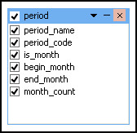

**Table Properties**

|  |  |  |  |  |
| --- | --- | --- | --- | --- |
| **period** | | | | |
| **Field Name** | **Description** | **Type** | **Length** | **Null** |
| period_name | Name of the period. | Text | 0 | Yes |
| period_code (PK) | Specify the period ID. It is auto increment. | Int | 11 | No |
| is_month | Specify it is month or not. | Text | 0 | Yes |
| begin_month | Specify the start month. | Int | 11 | Yes |
| end_month | Specify the end month. | Int | 11 | Yes |
| month_count | Specify total months. | Int | 11 | Yes |

## Chart Type

**Relationship Diagram**

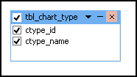 **Table Properties**

|  |  |  |  |  |
| --- | --- | --- | --- | --- |
| **tbl_chart_type** | | | | |
| **Field Name** | **Description** | **Type** | **Length** | **Null** |
| ctype_id (PK) | Specify the chart type ID. It is auto increment. | Varchar | 40 | No |
| ctype_name | Name of the chat type. | Varchar | 40 | Yes |

## Configuration Information

**Relationship Diagram**

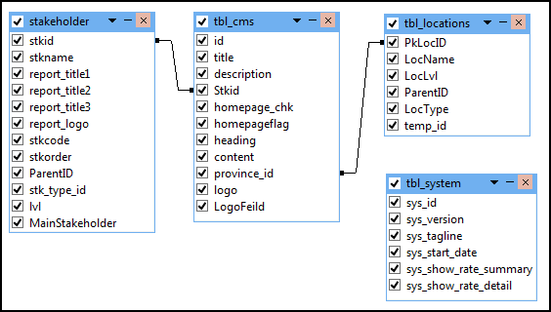

**Table Properties**

|  |  |  |  |  |
| --- | --- | --- | --- | --- |
| **tbl_system** | | | | |
| **Field Name** | **Description** | **Type** | **Length** | **Null** |
| sys_id (PK) | Specify the system ID. It is auto increment. | Smallint | 1 | No |
| sys_version |  | Float | 11 | Yes |
| sys_tagline |  | Varchar | 100 | Yes |
| sys_start_date |  | Varchar | 100 | Yes |
| sys_show_rate_summary |  | Smallint | 1 | Yes |
| sys_show_rate_detail |  | Smallint | 1 | Yes |

|  |  |  |  |  |
| --- | --- | --- | --- | --- |
| **tbl_cms** | | | | |
| **Field Name** | **Description** | **Type** | **Length** | **Null** |
| |  |  | | --- | --- | | id (PK) |  | | Specify the cms ID. It is auto increment. | int | 11 | No |
| |  |  |  | | --- | --- | --- | | title | varchar | 500 | |  | varchar | 500 | Yes |
| description |  | Text | 0 | Yes |
| Stkid (FK) | Specify the stakeholder ID. | Int | 11 | Yes |
| homepage_chk |  | Int | 1 | Yes |
| homepageflag |  | Tinyint | 1 | Yes |
| heading |  | Varchar | 500 | No |
| content |  | Varchar | 100 | No |
| province_id (FK) | Specify the location ID. | Int | 11 | No |
| logo |  | Varchar | 50 | No |
| LogoFeild |  | Int | 11 | Yes |

**cLMIS Screens**

# cLMIS Screens

## Home Screen

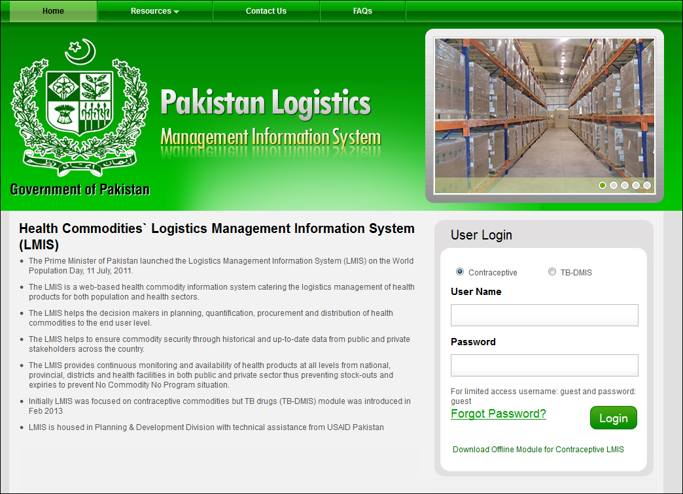

## Data Entry Screen

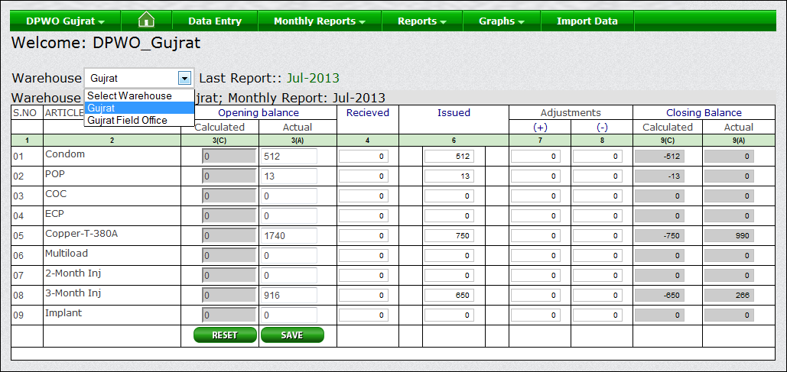

**LMIS Reports: National Summary Report**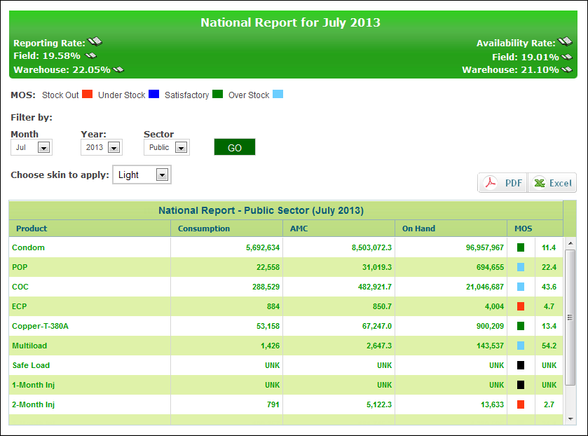

**LMIS Reports: Stakeholder Summary Report**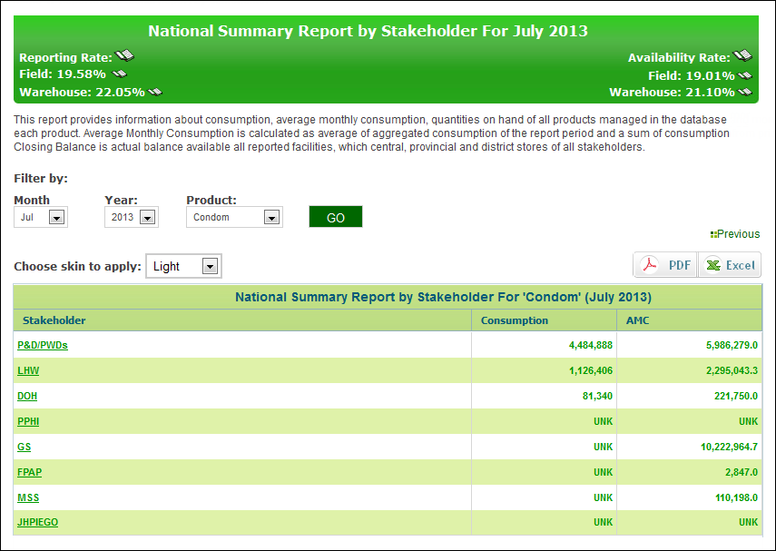

**LMIS Reports: Provincial Summary Report**

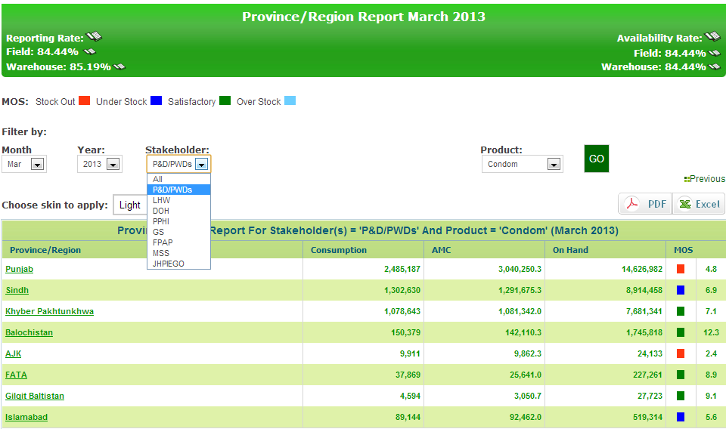

Select Stakeholder for which you want provincial data.

**LMIS Reports: District Summary Report**

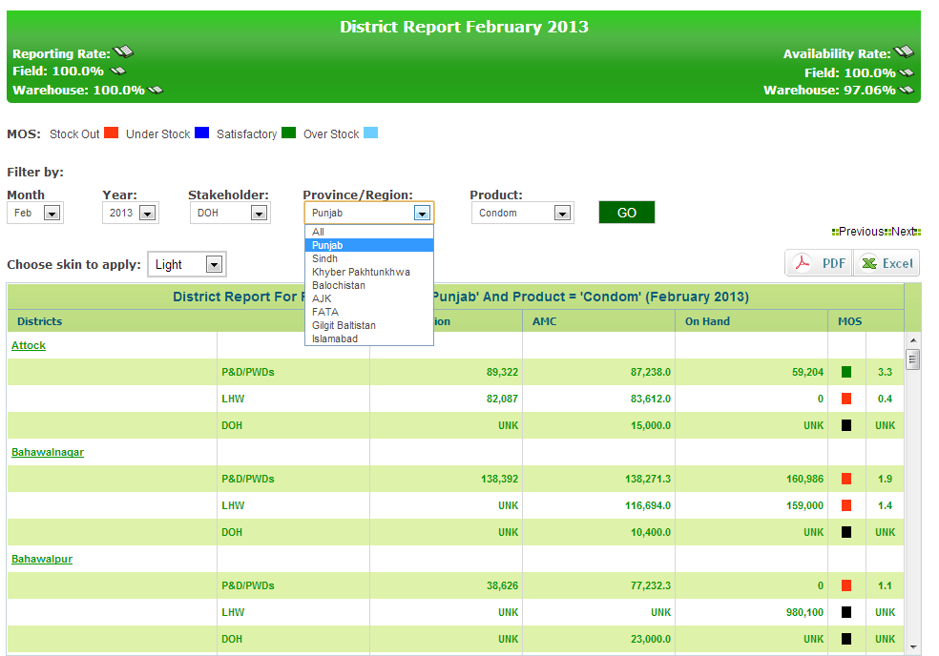

Select province for which you need District level Data.

**LMIS Reports: Field Summary Report**

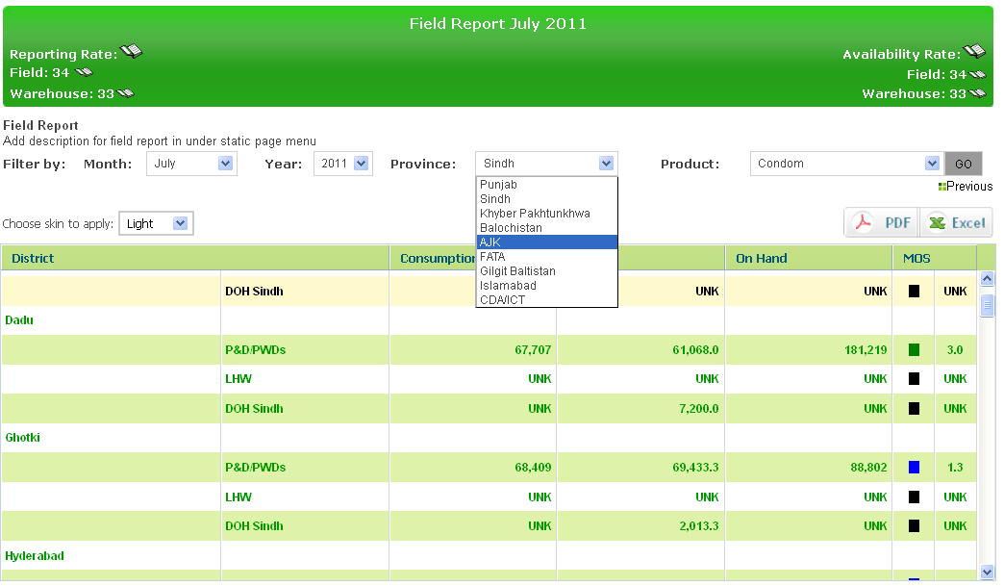

Select province for which you need District level Data.

Select Month, Year, Province, Product and click here.

**Stock Availability Report**

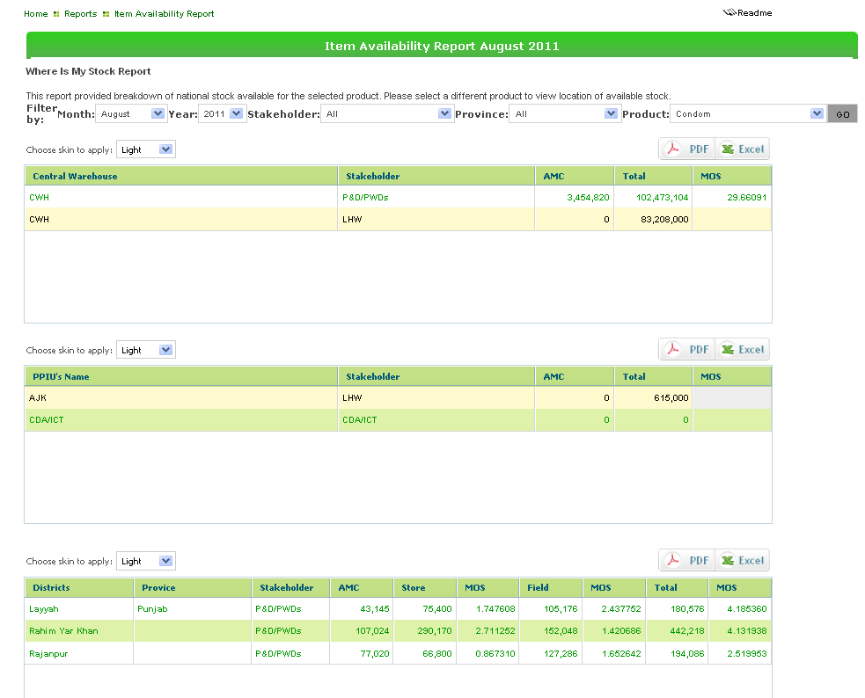

Select stakeholder.

Select province.

Select product and click Go.

Show filtered results of Districts.

Show filtered results of PPIU.

Show filtered results of central warehouses.

Generate PDF\Excel

**Non Reported Districts**

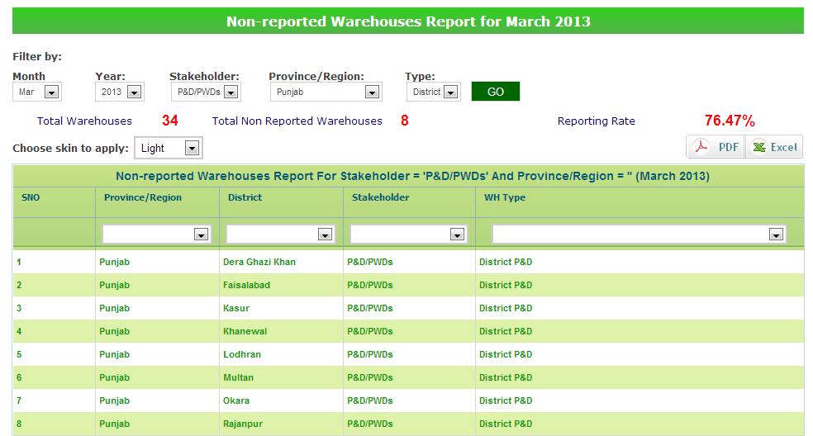

Select month, year, stakeholder, province and click Go.

Filter Results by province

Filter Results by District

Filter Results by Stakeholder

Filter results by Warehouse type

**Central Provincial Warehouse Yearly Report**

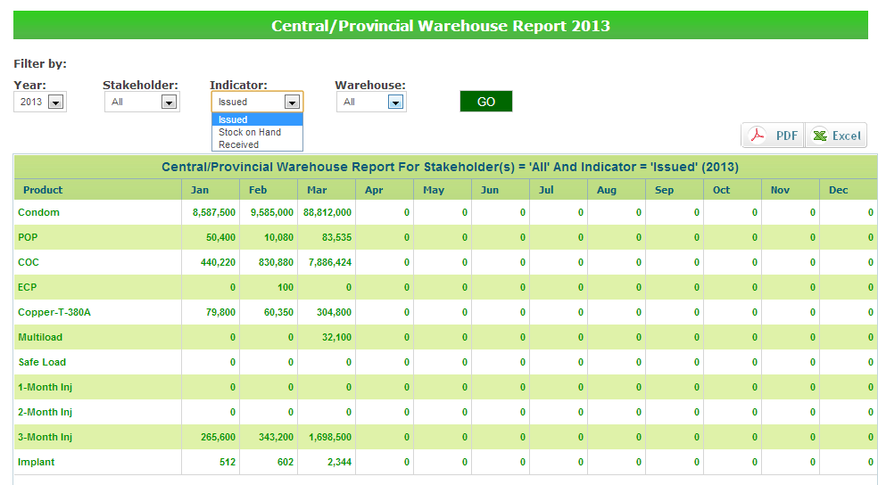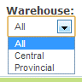

Select Filters

**Provincial Yearly Report**



Select Filters

**Private Sector Yearly Report**

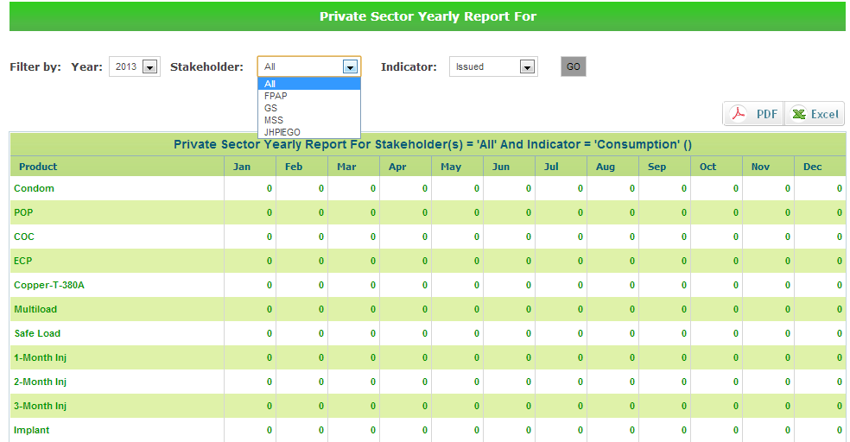

Select Filters

**Public Private Sector Report**

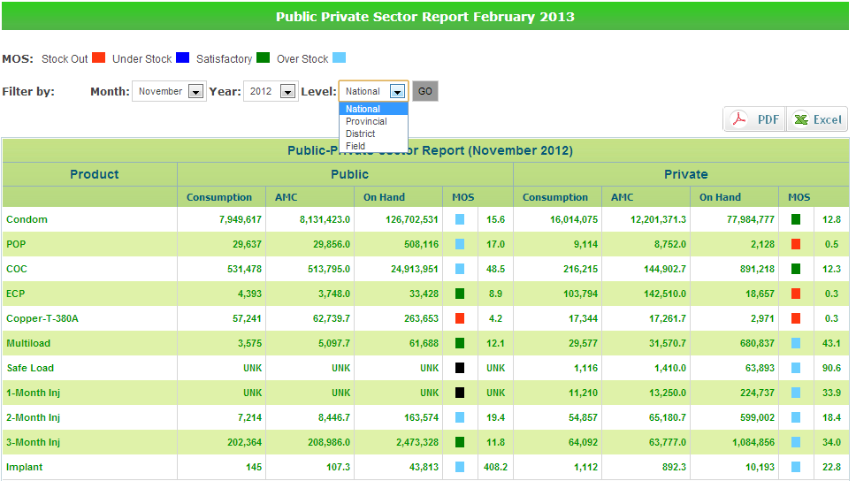

Select Filters



**Graphs  
  
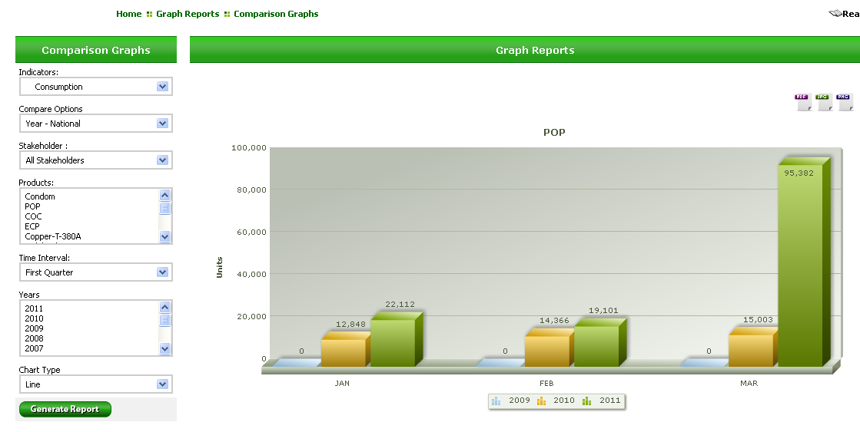**

**Offline Module**

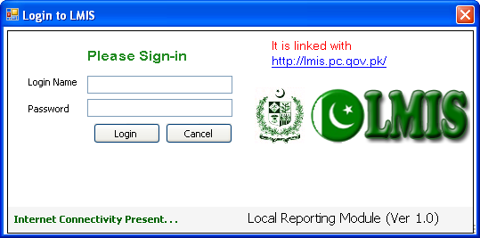

User Name

Password

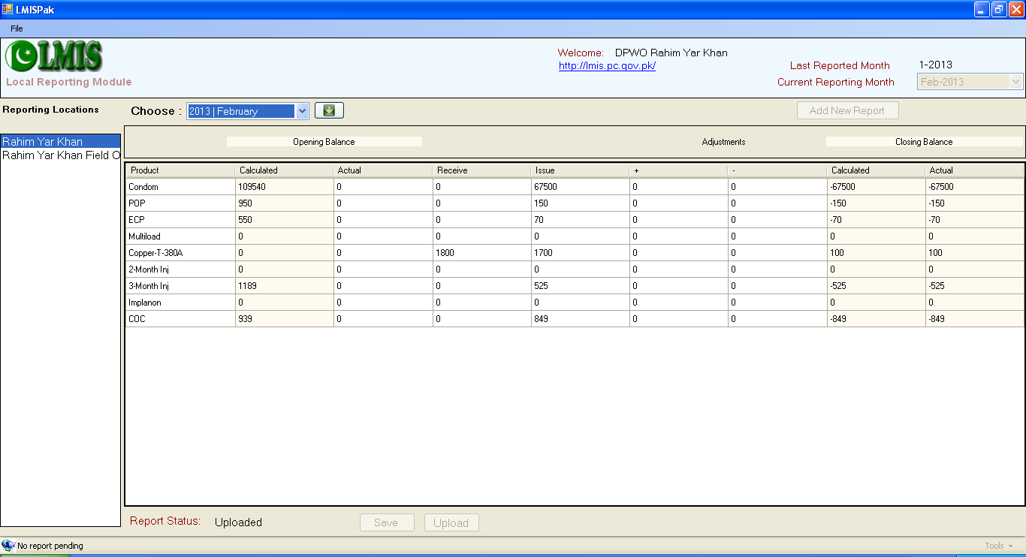

Select Report Month

Select Store or Warehouse

Input/View data of Report

Click to Save data in local database

Upload Status of Report

Click to Upload Report on Server

Click to Add New report

# Appendix 5: Glossary

HTTP: the set of rules for exchanging files (text, graphic images, sound, video, and other multimedia files) on the World Wide Web

HTTPS: HTTP with SSL (secure socket layer) encryption for security.

SQL: (Structured Query Language) Is a relational database query language.

